Collaborative Session 1
Esrat Ebtida Sakib
A3002558

Creating a simple server and client using Java RMI :
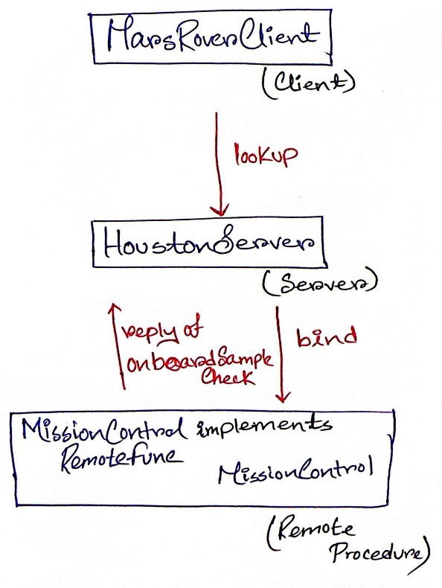
First let me explain the example that I have chosen: Mars Rover, Opportunity is sending collected sample’s raw data to a server, the Houston computer control in Texas. Houston computer here acts as a server and it has a plethora of remote function at its disposal. One of them is Mission Control. Mission Control packs a strong functionality that is – onboardSampleCheck. Here, client is the Mars Rover, Opportunity. Server is computer control in Houston, Texas and Remote function is Mission Control.

Figure 1: Scenario

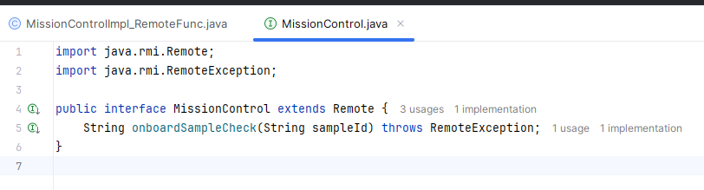
First I created the MissionControl Interface which extends to Java RMI class Remote.
Then I implemented this interface and created the class MissionControlImpl_RemoteFunc. This will work as our remote function. It houses the functionality that is required by client. For this scenario the functionality is – onboardSampleCheck. We extended to UnicastRemoteObject. It exports a remote object so that the object can accept incoming remote method calls over the network.
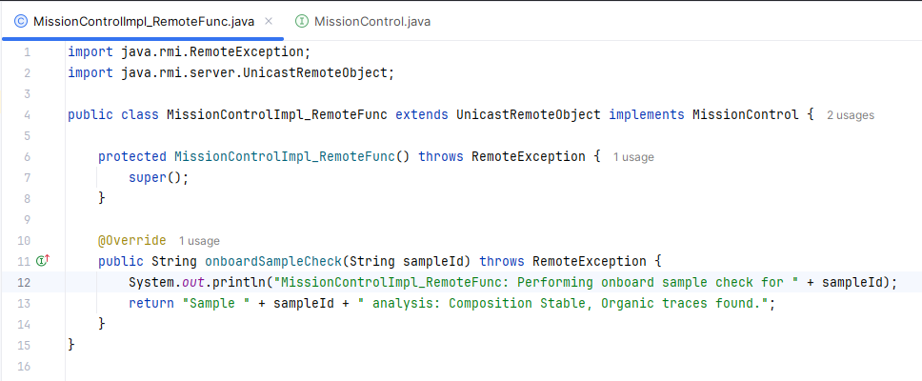
Then I created the executable server named HoustonServer. It binds MissionControlImpl_RemoteFunc with a URL in the network. The server also contains a health check in the form of printing in the console.
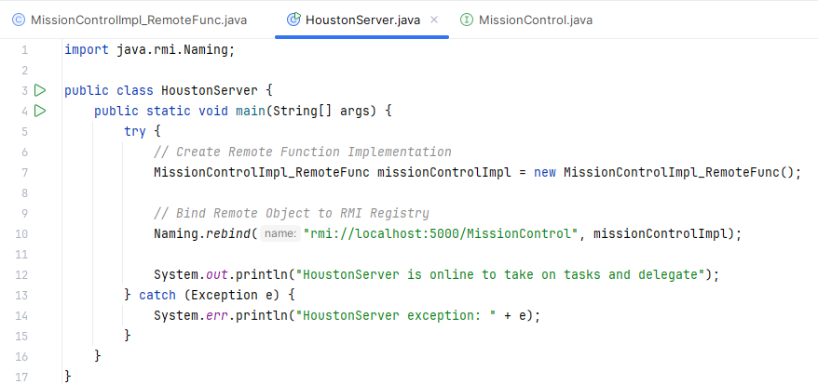

Finally the client was made with the Name: MarsRoverClient. It is an independently executable file. It looks up the RMI registry with the help of the MissionControl RMI by the URL.
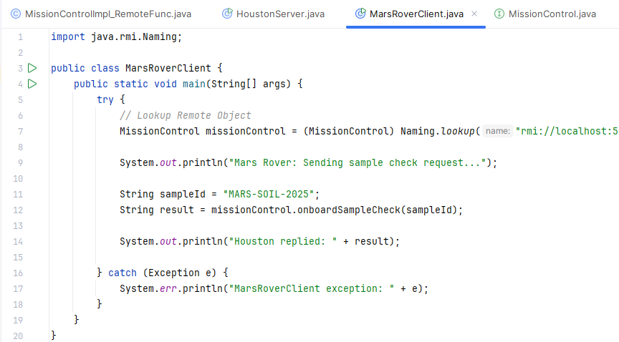

Execution and Result: At first we needed to start the rmiRegistry. We started that using the java command rmiregistry 5000.
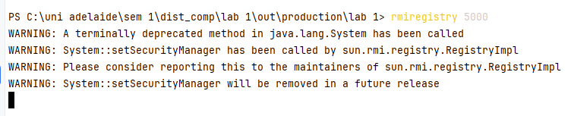
Once our registry was updated, we executed server and client separately. This yielded the following results –
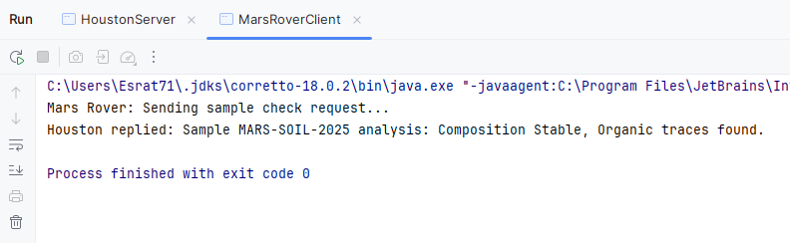
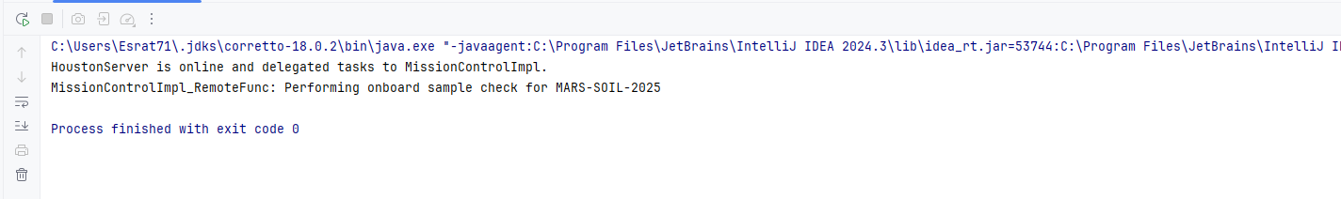

Execution summary via console log :
Client started -> “Mars Rover: Sending sample check request...” -> “HoustonServer is online and delegated tasks to MissionControlImpl.” -> “MissionControlImpl_RemoteFunc: Performing onboard sample check for MARS-SOIL-2025” -> “Houston replied: Sample MARS-SOIL-2025 analysis: Composition Stable, Organic traces found.”

Implementation maintains a persistent state
To showcase a persistent state, we have added a list named getSampleList. We have also added functions to add and remove samples from the list.
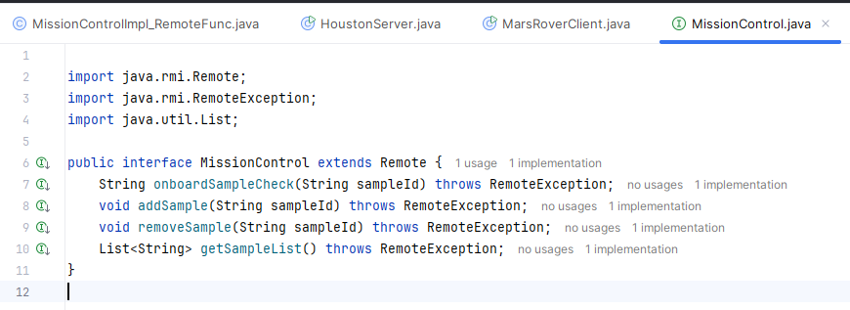
The implementation of this interface allows the server to add, remove and retrieve samples on behalf of the client. The list persists throughout the life cycle of the connection. MarsRoverClient sends rock samples one by one and it is saved in the list by the server. When the client tries to retrieve a sample’s data, server invokes the remote function of getting element from a list to get it and serve it to the client.
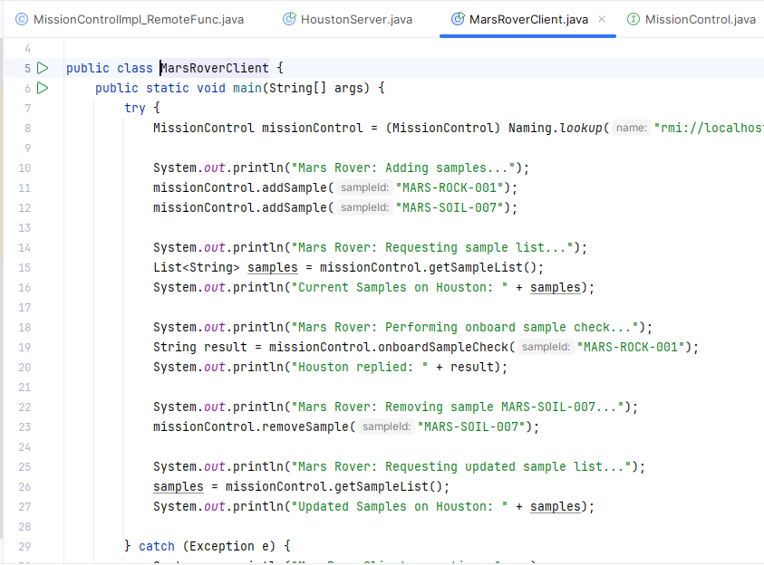

The console looks like this :
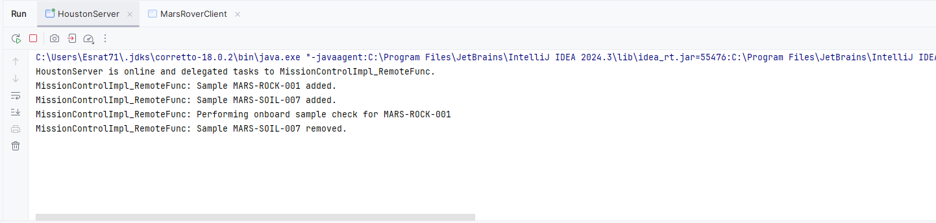
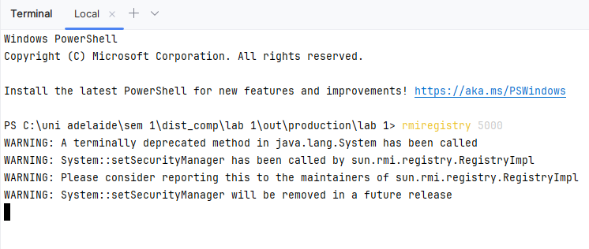
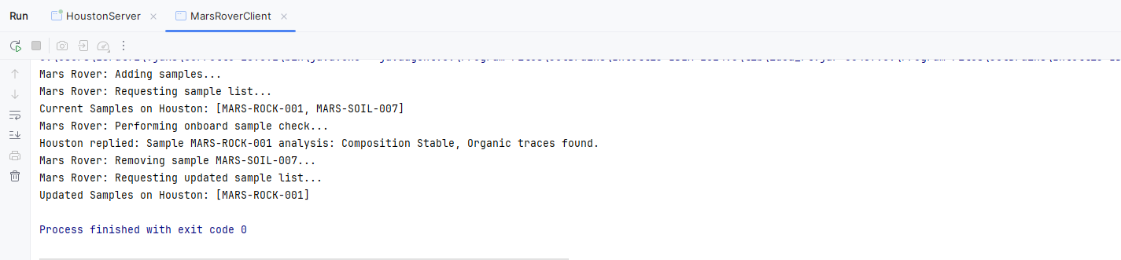

Creating Test
We will be doing Junit test here.
Test 1 -> Adding a sample ID to the server and verify it's reflected in the sample list
Expected result: [MARS-ROCK-001]
Test 2 -> Removing an existing sample ID from the server and verify it's deleted.
Expected result: Sample list should not contain MARS-SOIL-007
Test 3 -> Attempting to remove a sample ID that does not exist and verify the server handles gracefully.
Expected result: Server should log “Sample MARS-DUST-999 not found.” without exceptions.

Test Results :
